X文件的导出系列4——关键帧动画
首先在3DSMAX创建3个长方体，分别命名为Body，大小为10*10*10，将材质颜色设置为蓝色（其实使用X插件导出无需此步，但使用fbx导出时若不设置材质颜色，导出的模型漫反射颜色为默认的白色）；RightLeg，大小为3*3*10，材质颜色为红色；LeftLeg，大小为3*3*10，材质颜色为绿色。并将三者移动至合适的位置构成一个最简单的人体。如下图所示：
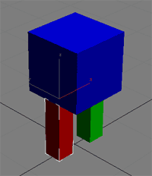
选择工具栏上的“选择并链接”图标将左右脚链接到身体上：

在图解视图中的层次结构如下：
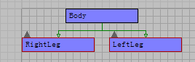
做到这步，其实与X文件的导出系列3——层级模型是一样的。
下面设置关键帧动画，选择右脚，开启“自动关键帧”，在第9帧将右脚旋转90度，形成一个提右脚的动画。在第10帧中将右脚回复到原位。对左脚进行同样的操作，只不过是在第10帧到第19帧提左脚。现在可拖动滑动条观看效果。
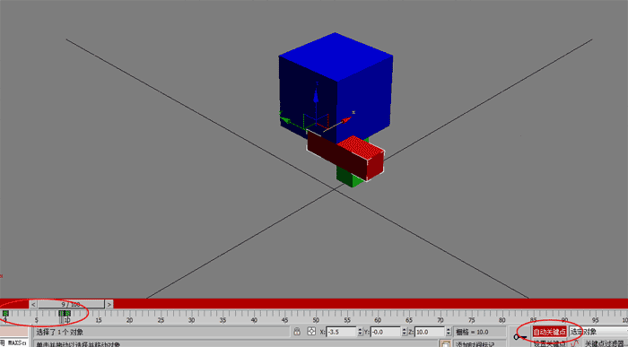
接下来导出这个文件，选择文件→导出，选择Panda DirectX插件（我现在用的是3DSMAX 2010，在http://www.andytather.co.uk/Panda/directxmax_downloads.aspx上下载的对应2010的插件），确定后弹出对话框：
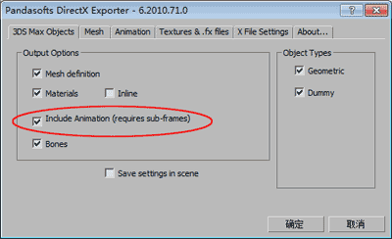
一定要勾选“Include Animation”选框，在“Animation”选项卡中如下操作：
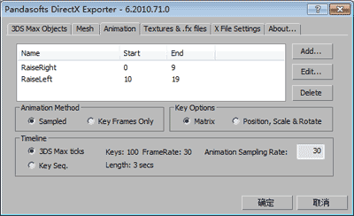
通过点击Add，添加动画，0至9帧是提右腿动画，我命名为RaiseRight，在添加一个10至19帧的提左腿动画RaiseLeft，其他选项保持默认，其实在KeyOptions中选择第二个也是可以的，具体原因下面会说到。确定后就可以获得导出的X文件了。
如果在DirectX View中查看这个文件，发现只会播放最后一个动画，不过这无关紧要，编程是可以实现播放两个动画中的任何一个的。
看一下源代码，源代码很长有所删减，主要看动画部分：

Frame Body {

//身体的变换矩阵
FrameTransformMatrix {
1.000000,0.000000,0.000000,0.000000,0.000000,1.000000,0.000000,0.000000,0.000000,0.000000,1.000000,0.000000,0.000000,10.000000,0.000000,1.000000;;
}

Mesh {
身体网格的顶点数据、略
…
MeshNormals {
法线数据略…
}

MeshMaterialList {

Material {
材质数据略…
}
}

MeshTextureCoords {
纹理坐标略…
}
}

Frame RightLeg {

//右脚的变换矩阵，可见右脚相对于它的父（身体）没有旋转，但向左平移了3.5个单位
FrameTransformMatrix {
1.000000,0.000000,0.000000,0.000000,0.000000,-1.000000,0.000000,0.000000,0.000000,-0.000000,-1.000000,0.000000,-3.500000,0.000000,0.000000,1.000000;;
}

Mesh {…

MeshNormals {
…
}

MeshMaterialList {
…
Material {
…
}
}

MeshTextureCoords {
…
}
}
}

Frame LeftLeg {

//左脚的变换矩阵，可见左脚相对于身体向右平移了3.5单位
FrameTransformMatrix {
1.000000,0.000000,0.000000,0.000000,0.000000,-1.000000,0.000000,0.000000,0.000000,-0.000000,-1.000000,0.000000,3.500000,0.000000,0.000000,1.000000;;
}

Mesh {
…

MeshNormals {
….
}

MeshMaterialList {
….
Material {
…
}
}

MeshTextureCoords {
…
}
}
}
}

//下面是动画数据，第一个动画是提右脚，名称就是插件中设置的RaiseRight
AnimationSet RaiseRight {

//身体的变化
Animation Anim-Body {

{ Body }

AnimationKey {
4; //第一个数字表示动画键，其中0表示旋转键，1表示缩放键，2表示位置键，4表示矩阵键，具体可参见网格模型高级技术（4），这是由插件中的Key Options选项决定的，你可以试着将Matrix改为Position，Scale&Rotation看看输出结果有什么不同。
10; //第二个数字表示帧数，这个动画有10帧
//下面第一个数字表示相对时间，依次是0,160,320…，第二个数字表示浮点数数量，因为使用的是4*4矩阵，所以为16，后面就是16个浮点数表示变换矩阵，从这个数据可知身体没有变化
0;16;1.000000,0.000000,0.000000,0.000000,0.000000,1.000000,0.000000,0.000000,0.000000,0.000000,1.000000,0.000000,0.000000,10.000000,0.000000,1.000000;;,
160;16;1.000000,0.000000,0.000000,0.000000,0.000000,1.000000,0.000000,0.000000,0.000000,0.000000,1.000000,0.000000,0.000000,10.000000,0.000000,1.000000;;,
320;16;1.000000,0.000000,0.000000,0.000000,0.000000,1.000000,0.000000,0.000000,0.000000,0.000000,1.000000,0.000000,0.000000,10.000000,0.000000,1.000000;;,
480;16;1.000000,0.000000,0.000000,0.000000,0.000000,1.000000,0.000000,0.000000,0.000000,0.000000,1.000000,0.000000,0.000000,10.000000,0.000000,1.000000;;,
640;16;1.000000,0.000000,0.000000,0.000000,0.000000,1.000000,0.000000,0.000000,0.000000,0.000000,1.000000,0.000000,0.000000,10.000000,0.000000,1.000000;;,
800;16;1.000000,0.000000,0.000000,0.000000,0.000000,1.000000,0.000000,0.000000,0.000000,0.000000,1.000000,0.000000,0.000000,10.000000,0.000000,1.000000;;,
960;16;1.000000,0.000000,0.000000,0.000000,0.000000,1.000000,0.000000,0.000000,0.000000,0.000000,1.000000,0.000000,0.000000,10.000000,0.000000,1.000000;;,
1120;16;1.000000,0.000000,0.000000,0.000000,0.000000,1.000000,0.000000,0.000000,0.000000,0.000000,1.000000,0.000000,0.000000,10.000000,0.000000,1.000000;;,
1280;16;1.000000,0.000000,0.000000,0.000000,0.000000,1.000000,0.000000,0.000000,0.000000,0.000000,1.000000,0.000000,0.000000,10.000000,0.000000,1.000000;;,
1440;16;1.000000,0.000000,0.000000,0.000000,0.000000,1.000000,0.000000,0.000000,0.000000,0.000000,1.000000,0.000000,0.000000,10.000000,0.000000,1.000000;;;
}
}

Animation Anim-RightLeg {

{ RightLeg }

AnimationKey {
4;
10;
//从以下数据可知右脚在旋转
0;16;1.000000,0.000000,0.000000,0.000000,0.000000,-1.000000,0.000000,0.000000,0.000000,-0.000000,-1.000000,0.000000,-3.500000,0.000000,0.000000,1.000000;;,
160;16;1.000000,0.000000,0.000000,0.000000,0.000000,-0.998549,-0.053842,0.000000,0.000000,0.053842,-0.998549,0.000000,-3.500000,0.000000,0.000000,1.000000;;,
320;16;1.000000,0.000000,0.000000,0.000000,0.000000,-0.980416,-0.196939,0.000000,0.000000,0.196939,-0.980416,0.000000,-3.500000,0.000000,0.000000,1.000000;;,
480;16;1.000000,0.000000,0.000000,0.000000,0.000000,-0.918216,-0.396079,0.000000,0.000000,0.396079,-0.918216,0.000000,-3.500000,0.000000,0.000000,1.000000;;,
640;16;1.000000,0.000000,0.000000,0.000000,0.000000,-0.793025,-0.609188,0.000000,0.000000,0.609188,-0.793025,0.000000,-3.500000,0.000000,0.000000,1.000000;;,
800;16;1.000000,0.000000,0.000000,0.000000,0.000000,-0.609189,-0.793025,0.000000,0.000000,0.793025,-0.609189,0.000000,-3.500000,0.000000,0.000000,1.000000;;,
960;16;1.000000,0.000000,0.000000,0.000000,0.000000,-0.396080,-0.918216,0.000000,0.000000,0.918216,-0.396080,0.000000,-3.500000,0.000000,0.000000,1.000000;;,
1120;16;1.000000,0.000000,0.000000,0.000000,0.000000,-0.196939,-0.980416,0.000000,0.000000,0.980416,-0.196939,0.000000,-3.500000,0.000000,0.000000,1.000000;;,
1280;16;1.000000,0.000000,0.000000,0.000000,0.000000,-0.053842,-0.998549,0.000000,0.000000,0.998549,-0.053842,0.000000,-3.500000,0.000000,0.000000,1.000000;;,
1440;16;1.000000,0.000000,0.000000,0.000000,0.000000,-0.000000,-1.000000,0.000000,0.000000,1.000000,-0.000000,0.000000,-3.500000,0.000000,0.000000,1.000000;;;
}
}

Animation Anim-LeftLeg {

{ LeftLeg }

AnimationKey {
4;
10;
//左脚没有变化
0;16;1.000000,0.000000,0.000000,0.000000,0.000000,-1.000000,0.000000,0.000000,0.000000,-0.000000,-1.000000,0.000000,3.500000,0.000000,0.000000,1.000000;;,
160;16;1.000000,0.000000,0.000000,0.000000,0.000000,-1.000000,0.000000,0.000000,0.000000,-0.000000,-1.000000,0.000000,3.500000,0.000000,0.000000,1.000000;;,
320;16;1.000000,0.000000,0.000000,0.000000,0.000000,-1.000000,0.000000,0.000000,0.000000,-0.000000,-1.000000,0.000000,3.500000,0.000000,0.000000,1.000000;;,
480;16;1.000000,0.000000,0.000000,0.000000,0.000000,-1.000000,0.000000,0.000000,0.000000,-0.000000,-1.000000,0.000000,3.500000,0.000000,0.000000,1.000000;;,
640;16;1.000000,0.000000,0.000000,0.000000,0.000000,-1.000000,0.000000,0.000000,0.000000,-0.000000,-1.000000,0.000000,3.500000,0.000000,0.000000,1.000000;;,
800;16;1.000000,0.000000,0.000000,0.000000,0.000000,-1.000000,0.000000,0.000000,0.000000,-0.000000,-1.000000,0.000000,3.500000,0.000000,0.000000,1.000000;;,
960;16;1.000000,0.000000,0.000000,0.000000,0.000000,-1.000000,0.000000,0.000000,0.000000,-0.000000,-1.000000,0.000000,3.500000,0.000000,0.000000,1.000000;;,
1120;16;1.000000,0.000000,0.000000,0.000000,0.000000,-1.000000,0.000000,0.000000,0.000000,-0.000000,-1.000000,0.000000,3.500000,0.000000,0.000000,1.000000;;,
1280;16;1.000000,0.000000,0.000000,0.000000,0.000000,-1.000000,0.000000,0.000000,0.000000,-0.000000,-1.000000,0.000000,3.500000,0.000000,0.000000,1.000000;;,
1440;16;1.000000,0.000000,0.000000,0.000000,0.000000,-1.000000,0.000000,0.000000,0.000000,-0.000000,-1.000000,0.000000,3.500000,0.000000,0.000000,1.000000;;;
}
}
}

AnimationSet RaiseLeft {

Animation Anim-Body {

{ Body }

AnimationKey {
4;
10;
0;16;1.000000,0.000000,0.000000,0.000000,0.000000,1.000000,0.000000,0.000000,0.000000,0.000000,1.000000,0.000000,0.000000,10.000000,0.000000,1.000000;;,
160;16;1.000000,0.000000,0.000000,0.000000,0.000000,1.000000,0.000000,0.000000,0.000000,0.000000,1.000000,0.000000,0.000000,10.000000,0.000000,1.000000;;,
320;16;1.000000,0.000000,0.000000,0.000000,0.000000,1.000000,0.000000,0.000000,0.000000,0.000000,1.000000,0.000000,0.000000,10.000000,0.000000,1.000000;;,
480;16;1.000000,0.000000,0.000000,0.000000,0.000000,1.000000,0.000000,0.000000,0.000000,0.000000,1.000000,0.000000,0.000000,10.000000,0.000000,1.000000;;,
640;16;1.000000,0.000000,0.000000,0.000000,0.000000,1.000000,0.000000,0.000000,0.000000,0.000000,1.000000,0.000000,0.000000,10.000000,0.000000,1.000000;;,
800;16;1.000000,0.000000,0.000000,0.000000,0.000000,1.000000,0.000000,0.000000,0.000000,0.000000,1.000000,0.000000,0.000000,10.000000,0.000000,1.000000;;,
960;16;1.000000,0.000000,0.000000,0.000000,0.000000,1.000000,0.000000,0.000000,0.000000,0.000000,1.000000,0.000000,0.000000,10.000000,0.000000,1.000000;;,
1120;16;1.000000,0.000000,0.000000,0.000000,0.000000,1.000000,0.000000,0.000000,0.000000,0.000000,1.000000,0.000000,0.000000,10.000000,0.000000,1.000000;;,
1280;16;1.000000,0.000000,0.000000,0.000000,0.000000,1.000000,0.000000,0.000000,0.000000,0.000000,1.000000,0.000000,0.000000,10.000000,0.000000,1.000000;;,
1440;16;1.000000,0.000000,0.000000,0.000000,0.000000,1.000000,0.000000,0.000000,0.000000,0.000000,1.000000,0.000000,0.000000,10.000000,0.000000,1.000000;;;
}
}

Animation Anim-RightLeg {

{ RightLeg }

AnimationKey {
4;
10;
0;16;1.000000,0.000000,0.000000,0.000000,0.000000,-1.000000,-0.000000,0.000000,0.000000,0.000000,-1.000000,0.000000,-3.500000,0.000000,0.000000,1.000000;;,
160;16;1.000000,0.000000,0.000000,0.000000,0.000000,-1.000000,-0.000000,0.000000,0.000000,0.000000,-1.000000,0.000000,-3.500000,0.000000,0.000000,1.000000;;,
320;16;1.000000,0.000000,0.000000,0.000000,0.000000,-1.000000,-0.000000,0.000000,0.000000,0.000000,-1.000000,0.000000,-3.500000,0.000000,0.000000,1.000000;;,
480;16;1.000000,0.000000,0.000000,0.000000,0.000000,-1.000000,-0.000000,0.000000,0.000000,0.000000,-1.000000,0.000000,-3.500000,0.000000,0.000000,1.000000;;,
640;16;1.000000,0.000000,0.000000,0.000000,0.000000,-1.000000,-0.000000,0.000000,0.000000,0.000000,-1.000000,0.000000,-3.500000,0.000000,0.000000,1.000000;;,
800;16;1.000000,0.000000,0.000000,0.000000,0.000000,-1.000000,-0.000000,0.000000,0.000000,0.000000,-1.000000,0.000000,-3.500000,0.000000,0.000000,1.000000;;,
960;16;1.000000,0.000000,0.000000,0.000000,0.000000,-1.000000,-0.000000,0.000000,0.000000,0.000000,-1.000000,0.000000,-3.500000,0.000000,0.000000,1.000000;;,
1120;16;1.000000,0.000000,0.000000,0.000000,0.000000,-1.000000,-0.000000,0.000000,0.000000,0.000000,-1.000000,0.000000,-3.500000,0.000000,0.000000,1.000000;;,
1280;16;1.000000,0.000000,0.000000,0.000000,0.000000,-1.000000,-0.000000,0.000000,0.000000,0.000000,-1.000000,0.000000,-3.500000,0.000000,0.000000,1.000000;;,
1440;16;1.000000,0.000000,0.000000,0.000000,0.000000,-1.000000,-0.000000,0.000000,0.000000,0.000000,-1.000000,0.000000,-3.500000,0.000000,0.000000,1.000000;;;
}
}

Animation Anim-LeftLeg {

{ LeftLeg }

AnimationKey {
4;
10;
0;16;1.000000,0.000000,0.000000,0.000000,0.000000,-1.000000,0.000000,0.000000,0.000000,-0.000000,-1.000000,0.000000,3.500000,0.000000,0.000000,1.000000;;,
160;16;1.000000,0.000000,0.000000,0.000000,0.000000,-0.998549,-0.053842,0.000000,0.000000,0.053842,-0.998549,0.000000,3.500000,0.000000,0.000000,1.000000;;,
320;16;1.000000,0.000000,0.000000,0.000000,0.000000,-0.980416,-0.196939,0.000000,0.000000,0.196939,-0.980416,0.000000,3.500000,0.000000,0.000000,1.000000;;,
480;16;1.000000,0.000000,0.000000,0.000000,0.000000,-0.918216,-0.396079,0.000000,0.000000,0.396079,-0.918216,0.000000,3.500000,0.000000,0.000000,1.000000;;,
640;16;1.000000,0.000000,0.000000,0.000000,0.000000,-0.793025,-0.609188,0.000000,0.000000,0.609188,-0.793025,0.000000,3.500000,0.000000,0.000000,1.000000;;,
800;16;1.000000,0.000000,0.000000,0.000000,0.000000,-0.609189,-0.793025,0.000000,0.000000,0.793025,-0.609189,0.000000,3.500000,0.000000,0.000000,1.000000;;,
960;16;1.000000,0.000000,0.000000,0.000000,0.000000,-0.396080,-0.918216,0.000000,0.000000,0.918216,-0.396080,0.000000,3.500000,0.000000,0.000000,1.000000;;,
1120;16;1.000000,0.000000,0.000000,0.000000,0.000000,-0.196939,-0.980416,0.000000,0.000000,0.980416,-0.196939,0.000000,3.500000,0.000000,0.000000,1.000000;;,
1280;16;1.000000,0.000000,0.000000,0.000000,0.000000,-0.053842,-0.998549,0.000000,0.000000,0.998549,-0.053842,0.000000,3.500000,0.000000,0.000000,1.000000;;,
1440;16;1.000000,0.000000,0.000000,0.000000,0.000000,0.000000,-1.000000,0.000000,0.000000,1.000000,0.000000,0.000000,3.500000,0.000000,0.000000,1.000000;;;
}
}
}

你也可以使用kW-export导出，这个插件网址为http://kwxport.sourceforge.net/，但下载需要注册，本地下载地址为，导出时选择这个插件，弹出对话框如下图所示：
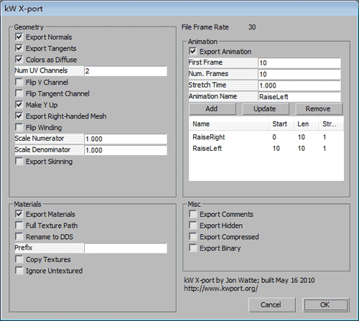
单击OK，导出文件，如果看一下源文件，发现与Panda导出的类似，但它的动画是使用Position、Scale&Rotation的形式，例如：
AnimationSet RaiseRight {

Animation Anim-RaiseRight-Body {

{ Body }

AnimationKey rot {
0;
1;
0;4;1.000000,0.000000,0.000000,0.000000;;;
}

AnimationKey scale {
1;
1;
0;3;1.000000,1.000000,1.000000;;;
}

AnimationKey pos {
2;
1;
0;3;0.000000,10.000000,0.000000;;;
}
}

Animation Anim-RaiseRight-RightLeg {

{ RightLeg }

AnimationKey rot {
0;
10;
0;4;-0.000000,1.000000,0.000000,0.000000;;,
160;4;0.026931,0.999637,0.000000,0.000000;;,
320;4;0.098955,0.995092,0.000000,0.000000;;,
480;4;0.202217,0.979341,0.000000,0.000000;;,
640;4;0.321694,0.946844,0.000000,0.000000;;,
800;4;0.442047,0.896992,0.000000,0.000000;;,
960;4;0.549509,0.835488,0.000000,0.000000;;,
1120;4;0.633664,0.773608,0.000000,0.000000;;,
1280;4;0.687807,0.725893,0.000000,0.000000;;,
1440;4;0.707107,0.707107,0.000000,0.000000;;;
}

AnimationKey scale {
1;
1;
0;3;1.000000,1.000000,1.000000;;;
}

AnimationKey pos {
2;
1;
0;3;-3.500000,0.000000,0.000000;;;
}
}

Animation Anim-RaiseRight-LeftLeg {

{ LeftLeg }

AnimationKey rot {
0;
1;
0;4;-0.000000,1.000000,0.000000,0.000000;;;
}

AnimationKey scale {
1;
1;
0;3;1.000000,1.000000,1.000000;;;
}

AnimationKey pos {
2;
1;
0;3;3.500000,0.000000,0.000000;;;
}
}
}
最后，你也可以使用3DSMAX自带的fbx插件导出fbx文件，除了将导出文件的格式变为ASCII，其他保持默认即可。
在我的引擎中观察三者没有区别（当然应该没有），从左自由分别是pandaX，KW导出的X和fbx
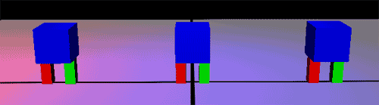
但是在Deep Exploration中观察这三者的动画其实是有区别的，pandaX只会播放第二个动画，KW导出的X两条腿会一起提升，只有fbx是依次播放两个动画的。
但最重要的一点，既然文件中已经包含了动画数据，那么如何播放它呢？答案是自己编写内容处理器将这些数据放在模型的Tag属性中，但是关键帧动画不能被XNA官网的SkinningModel示例处理，其实我读懂了这个示例后，发现处理这种动画简单地多，但其实没有必要，与其编写一个自定义导入器，还不如像层次模型动画—坦克2一样将动画控制代码写在模型类中，这就和控制坦克的炮塔或炮管的情况是一样的。
那么，符合XNA官网的SkinningModel要求的模型应该如何制作？将会在下一个教程中讨论。

